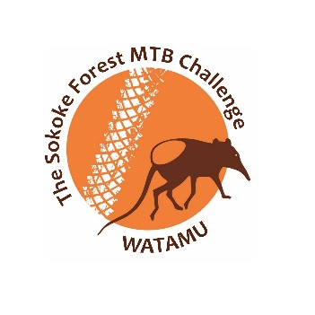
Sokoke Forest MTB Challenge 2023

Information Page
- Racing for Conservation –
20th _ 21st May 2023 – Watamu, Kenya
Thank you for your interest in the 2023 Sokoke Forest MTB Challenge – we’re looking forward to the event and hope you can join us in Watamu on Saturday 20th for an Untimed Fun Ride and/or for the Family Fun Ride and the Main Challenge on Sunday the 21st.

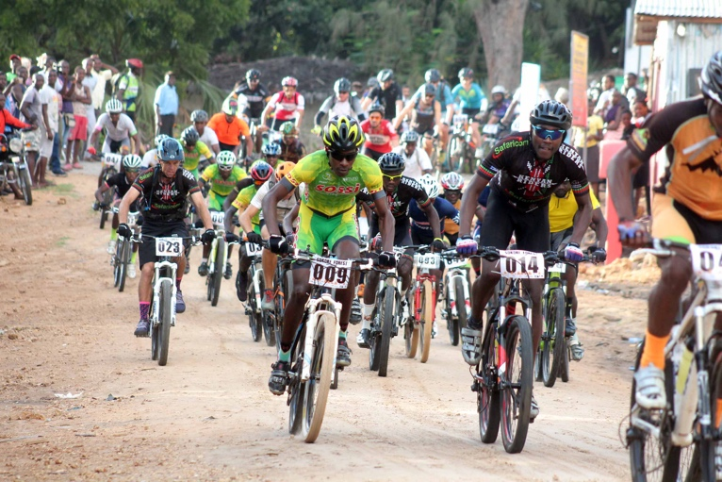
The Sokoke Forest MTB Challenge was started to both provide a chance for cyclists to enjoy some of our diverse and challenging coastal riding conditions as well as to raise funds for the conservation of Arabuko-Sokoke Forest through which the race takes place.

Funds are used to issue Eco-bursaries for secondary school for children of forest adjacent families through A Rocha Kenya’s programme the Arabuko-Sokoke Schools & Eco-Tourism Scheme (ASSETS). ‘Eco-bursaries’ are not just support for school fees but involve direct conservation action for the forest and adjacent Mida Creek.

Over 731 children have now been supported through four years of secondary school with ASSETS eco-bursaries and many have gone on to university and have jobs to support their families. The perceptions and behaviour of these families towards the forest has significantly improved as a result.

Hopefully you will have got the message about raising sponsorship for your ride to contribute to ASSETS (there’s a prize for whoever raises the most sponsorship!). All contributions are appreciated and will make a difference for a child – and the forest.

We are of course delighted to be partnering with the Kenya Forest Service for this event and also have the support of Kenya Wildlife Service at Arabuko-Sokoke Forest. We are grateful for their enthusiastic support for both this event and ASSETS itself.

Turtle Bay Beach Club and Ocean Sports Resort have played a key role in making the event happen and Lordship Africa have underwritten the key costs of the race for which we are also grateful. NIC Bank Watamu have also made a large donation – Asante!

The Route
The Sokoke Forest MTB Challenge is a unique ride starting and ending at Turtle Bay Beach Club, Watamu. The first half of the race takes riders through coconut and cashew nut plantations and mangrove forest before climbing up beside the Arabuko-Sokoke Forest to the Madunguni plateau overlooking the Sabaki River. A series of single-track footpaths ensue including two fast descents with subsequent tough ascents up the plateau escarpment.

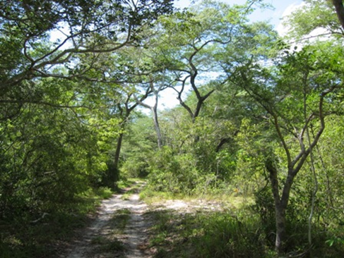
This leads competitors to the north-western entrance to Arabuko-Sokoke Forest at Jilore where the route enters the forest and you have a hard-packed fast road through dense forest that holds Africa’s smallest owl, the Sokoke Scops Owl, the bizarre and threatened Golden-rumped Sengi or Elephant-shrew as well as buffalo and elephant before dropping down to the white sandy soils with the beautiful, open miombo woodland habitat. These sands can be soft, making for tough cycling though being in the wet season and therefore with rain around they should be compacted enough to allow bikes to pass.
18 km of forest riding brings riders back to the edge of the mangroves of Mida Creek for a brief ride on fisherman trails before the final run down through the coconuts again to finish by the sparkling blue sea and white sand of Turtle Bay Beach Club. Total distance: 74 km

The Sokoke Forest MTB Challenge 2023 will have two main events on Day One – the Men’s Challenge and the Women’s Challenge, both following the same route but allowing women to race more competitively against equal opponents. Each event has over Ksh 100,000 of cash prizes.

The event also includes a ‘Fun Ride’ suited for children and families on Day Two as well as the more extreme Challenge on day one so as to suit riders of varying stamina spread over a full weekend in an event that has attracted a good number of enthusiasts.

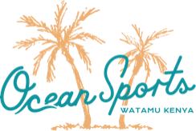
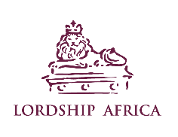
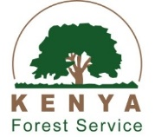
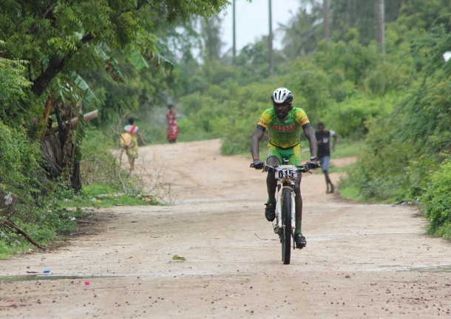
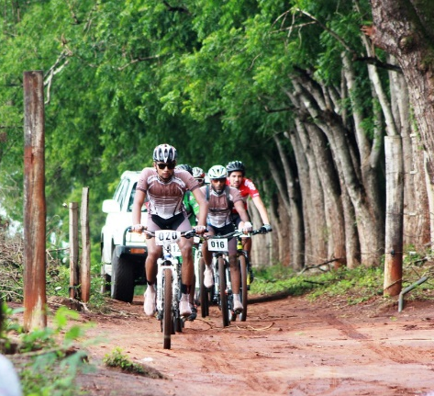

Race Information
Location: Watamu, Kenya - 3°21'45.7"S 40°00'10.7"E

DATE: 20th May 2022
Untimed Fun Ride
Distance: 50 KM
MTB/Gravel ride has been set for those interested which will leave at 6am from Turtle Bay and head towards Sabaki river, loop to Malindi for a stop at superb Italian coffee & croissant café, onward along the coastline on return.

DATE: 20th May 2022
Family Fun Ride
Distance: 10 KM
Registration Fee: Ksh 1,000 Adults
Ksh 500 Kids (12 and under)

DATE:21st May 2022
The Main Challenge
Distance: 70KM

Registration Fee:
Group/ Team( 5 riders) : Ksh 15,000
Single entry: Ksh 3,500
Community Riders: Ksh2,500
Registration deadline 19th May 2022

Prizes
There are over Ksh 200,000 of cash prizes to be won as well as a number of other prizes:

Cash prizes
Men:
1st = Ksh 50,000
2nd = Ksh 30,000
3rd = Ksh 15,000
4th = Ksh 7,000
5th =Ksh 3,000

Women:
1st = Ksh 50,000
2nd = Ksh 30,000
3rd = Ksh 15,000
4th = Ksh 7,000
5th = Ksh 3,000
Non-cash prizes will be awarded for the following additional categories:

- Most funds raised for forest conservation
- Youngest Finisher
- Best time over 50 years
- Best time over 60 years

Race Weekend Key Programme Waypoints

- All participants signing in for The Challenge, collection of race number – Saturday 20th May from 10am pm at Turtle Bay Beach Club

- Race Briefing –Saturday 20th May, 5pm at Turtle Bay Beach Club

- Sokoke Forest MTB Challenge will start at 7:00am, Sunday 21st May from Turtle Bay Beach Club

- Prize-giving – 2:30pm, Sunday 21st May at Turtle Bay Beach Club

- Untimed Fun Ride Registration – open from Friday 19th May at Turtle Bay Beach Club (the ride will start 6:00am at Turtle Bay Beach Club- please keep time)

- Family Fun Ride will start at 8:30 am - Saturday 20th May from Turtle Bay Beach Club
- Family Fun Ride Award giving – 10 am, Saturday 20th May at Turtle Bay Beach Club

Payment Options:
- Mpesa [Pay bill 303030 Account No: 0121008254]
- Cash

